**A PRELIMINARY REPORT ON**

**E-COMMERCE WEBSITE**

**SUBMITTED TO THE VISHWAKARMA INSTITUTE OF INFORMATION TECHNOLOGY, PUNE**

**IN THE PARTIAL FULFILLMENT OF THE REQUIREMENTS**

**FOR THE AWARD OF THE DEGREE**

**OF**

**BACHELOR OF TECHNOLOGY (COMPUTER ENGINEERING)**

##### SUBMITTED BY



|  |  |  |
| --- | --- | --- |
| **STUDENT NAME** | **Gr. No.** | **Roll. No.** |
| Aman Jain | 22110370 | 323001 |
| Ruchik Bhokare | 22110018 | 323008 |
| Saurabh Raut | 22110178 | 323055 |

## 

## DEPARTMENT OF COMPUTER ENGINEERING

**BRACT’S**

**VISHWAKARMA INSTITUTE OF INFORMATION TECHNOLOGY**

**SURVEY NO. 3/4, KONDHWA (BUDRUK), PUNE – 411048, MAHARASHTRA (INDIA).**

|  |  |  |  |  |  |  |
| --- | --- | --- | --- | --- | --- | --- |
| **Sr. No.** | | | | **Title of Chapter** | | **Page No.** |
| **01** | | | | **Introduction** | |  |
|  | 1.1 | | | Overview | |  |
|  | 1.2 | | | Motivation | |  |
|  | 1.3 | | | Problem Definition and Objectives | |  |
|  | 1.4 | | | Project Scope & Limitations | |  |
|  | 1.5 | | | Methodologies of Problem solving | |  |
| **02** | | | | Literature Survey | |  |
| **03** | | | | System Design | |  |
|  | | 3.1 | | System Architecture | |  |
| **04** | | | | Project Implementation | |  |
|  | | | 4.1 | Overview of Project Modules | |  |
|  | | | 4.2 | Tools and Technologies Used | |  |
|  | | | 4.3 | Algorithm Details | |  |
|  | | |  | 4.3.1 | Algorithm 1 |  |
|  | | |  | 4.3.2 | Algorithm 2 |  |
|  | | |  | 4.3.3 | … |  |
| **05** | | | | Results | |  |
|  | | | 5.1 | Outcomes | |  |
|  | | | 5.2 | Screen Shots | |  |
|  | | | 5.3 | Confusion Matrix, Precision ,Recall,Accuracy,Specificity ,Sensitivity All Graph | |  |
| **06** | | | | Conclusions | |  |
|  | | 9.1 | | Conclusions | |  |
|  | | 9.2 | | Future Work | |  |
|  | | 9.3 | | Applications | |  |
|  | | | |  | |  |
|  | | | | **Reference :** | |  |
|  | | | |  | |  |

**1.Introduction -**

**1.1 Overview**

In this introduction, we delve into the fundamental aspects of our project. We'll outline the core concepts, objectives, and methodologies driving our endeavor. By providing a comprehensive overview, readers will gain a clear understanding of the scope and purpose of our work.

**1.2 Motivation**

Understanding the motivation behind any project is crucial. In this section, we'll elucidate the driving forces that inspired us to embark on this journey. By articulating our motivations, we aim to convey the significance and relevance of our project to stakeholders and interested parties.

**1.3 Problem Definition and Objectives**

Every project begins with a problem to solve. In this section, we'll define the specific problem or challenge we aim to address. Additionally, we'll outline the objectives we hope to achieve through our efforts. By clearly defining the problem and objectives, we establish a framework for our project's execution and evaluation.

**1.4 Project Scope & Limitations**

While our aspirations may be vast, every project operates within defined boundaries. In this section, we'll delineate the scope of our project, detailing the extent of our endeavors and the areas we intend to cover. Additionally, we'll acknowledge any limitations or constraints that may impact our project's execution. By setting clear boundaries, we ensure realistic expectations and effective resource allocation.

**1.5 Methodologies of Problem Solving**

Approaching problems systematically is essential for success. In this section, we'll elucidate the methodologies and approaches we intend to employ in solving the defined problem. Whether through analytical frameworks, experimental methods, or innovative techniques, we'll outline our strategies for problem-solving. By articulating our methodologies, we provide transparency into our process and enable stakeholders to assess the rigor and efficacy of our approach.

# 

# 

# 2. Literature Survey :

|  |  |
| --- | --- |
| Author(s) and Year Research Outcome | Author(s) and Year Research Outcome |
| (Punhani and Batra, 2014) | The comparative analysis shows that it is important that e-commerce website designers consider the local cultural aspects when designing the website to reflect the local users’ emotions, thoughts, desires, and most importantly the culture. The important conclusion from the case study was that different countries’ e-commerce website users have diverse preferences and motives to use global e-commerce websites. |
| (Shahdadnejad and Nakhaie, 201 | The findings of their case study indicated that if the e-commerce website is presented in the consumer’s language, the number of individuals visiting the e-commerce website will be four times higher than the usual number of visitors. Another point in the study was the type of advertisements placed in the ecommerce website, which are also an important aspect to consider. The advertisements appropriate in one culture may not be suitable for another culture. |
| (Asimionoaei, 2009) | The research shows that e-commerce web page design and colours used on the web page have diverse emotional and social consequences in the global cultural community. The language is another important factor along with culture when designing an ecommerce website. E-commerce businesses need to develop their websites with choices for numerous languages. This study concluded that to have a successful e-commerce business, an e-commerce website development process must pay sincere attention to global culture |
| (Lo and Gong, 2005) | The research found that there is a need for e-commerce website designers to think through the influence of local culture and how the local culture motivates a user’s perception. For example, there is a greater occurrence of red colour in Chinese websites. |

**3. System Design**

The GeminiWear e-commerce platform's system design is built around a three-tier architecture that facilitates a seamless user experience while ensuring efficient data management and secure transactions.

## 3.1 System Architecture

The platform follows a three-tier architecture, consisting of the following layers:

1. Presentation Layer (Frontend)
   * Technologies: React and TypeScript.
   * Provides an interactive and responsive user interface for browsing and customizing products, managing carts, and placing orders.
   * Handles user interactions and inputs, such as product customization options.
   * Communicates with the backend services using RESTful APIs.
2. Application Layer (Backend)
   * Technologies: Node.js and Express.js.
   * Exposes RESTful APIs to serve data to the frontend and handle requests.
   * Manages business logic, including product and order management, user authentication, and authorization.
   * Integrates with third-party services such as payment gateways for processing transactions and shipping APIs for order fulfillment.
   * Implements caching and performance optimization techniques.
3. Data Layer
   * Technologies: MongoDB (NoSQL database).
   * Stores data related to products, users, orders, and reviews in a flexible and efficient manner.
   * Supports querying and indexing for fast data retrieval.
   * Manages data relationships using references within collections.

## Project Implementation

## 4.1 Overview of Project Modules

1. Product Customization
   * Allows users to customize apparel and accessories with different design options such as color, size, patterns, and text.
   * Provides a live preview feature that displays the customized product in real-time.
2. Product Management
   * Provides an admin interface for managing products, categories, descriptions, and inventory levels.
   * Supports adding, editing, and removing products, as well as organizing them into categories.
3. Order Processing
   * Handles user orders, including order creation, updates, and tracking.
   * Coordinates between the application layer and external services such as shipping APIs.
4. Payment Integration
   * Integrates with third-party payment gateways like Stripe or PayPal for secure and reliable payment processing.
   * Supports various payment methods and currencies to cater to a global audience.

## 

## 4.2 Tools and Technologies Used

* Frontend: React, TypeScript, and CSS for creating a responsive and interactive user interface.
* Backend: Node.js and Express.js for building RESTful APIs and managing business logic.
* Database: MongoDB for storing data related to products, users, orders, and reviews.
* Caching: Redis for implementing caching strategies and enhancing performance.
* Payment Gateway: Integration with Stripe and PayPal for secure payment processing.
* Monitoring and Logging: Tools such as Prometheus or Grafana for application monitoring and logging mechanisms.

## 4.3 Algorithm Details

### **4.3.1 Algorithm 1: Product Customization**

1. Input: User selections for customization options such as color, size, patterns, and text.
2. Process: Calculate the final design based on user inputs.
3. Output: Display the customized product to the user in real-time.

### **4.3.2 Algorithm 2: Order Processing**

1. Input: User order details and payment information.
2. Process: Validate the order and process the payment.
3. Output: Confirmation and order tracking information.

### **4.3.3 Algorithm 3: Product Recommendation**

1. Input: User browsing history, purchase history, and product metadata.
2. Process: Utilize collaborative filtering or content-based filtering algorithms to recommend similar or related products.
3. Output: Personalized product recommendations for the user.

**5. Results**

**5.1 Outcomes**

The outcomes of the e-commerce website for the clothing center can be assessed across various dimensions, including financial, operational, and customer satisfaction metrics.

Financial Outcomes:

* Increased Sales Revenue: The implementation of the e-commerce website has likely led to a significant increase in sales revenue for the clothing center. By providing customers with a convenient platform to browse and purchase products online, the website has expanded the reach of the clothing center beyond its physical storefront, tapping into a wider customer base.
* Cost Savings: The transition to online sales may have resulted in cost savings for the clothing center compared to traditional brick-and-mortar operations. Reduced overhead costs associated with physical retail spaces, such as rent, utilities, and staffing, can contribute to improved profitability.

Operational Outcomes:

* Streamlined Inventory Management: The e-commerce website's backend system likely includes robust inventory management capabilities, allowing the clothing center to efficiently track stock levels, manage product variants and SKUs, and implement automated reorder processes. This streamlines operations and minimizes the risk of stockouts or overstocking.
* Enhanced Order Processing Efficiency: Automated order processing workflows enable the clothing center to fulfill customer orders promptly and accurately. Integration with shipping carriers and logistics providers further streamlines the fulfillment process, ensuring timely delivery to customers.

Customer Satisfaction Metrics:

* Improved User Experience: The user-friendly interface and intuitive navigation of the e-commerce website contribute to an enhanced shopping experience for customers. Features such as product search, filtering options, and personalized recommendations enhance usability and convenience.
* Secure Payment Processing: Integration with secure payment gateways provides customers with confidence in the security of their transactions. Features such as SSL encryption and PCI compliance reassure customers that their payment information is protected.

**Screenshots :**



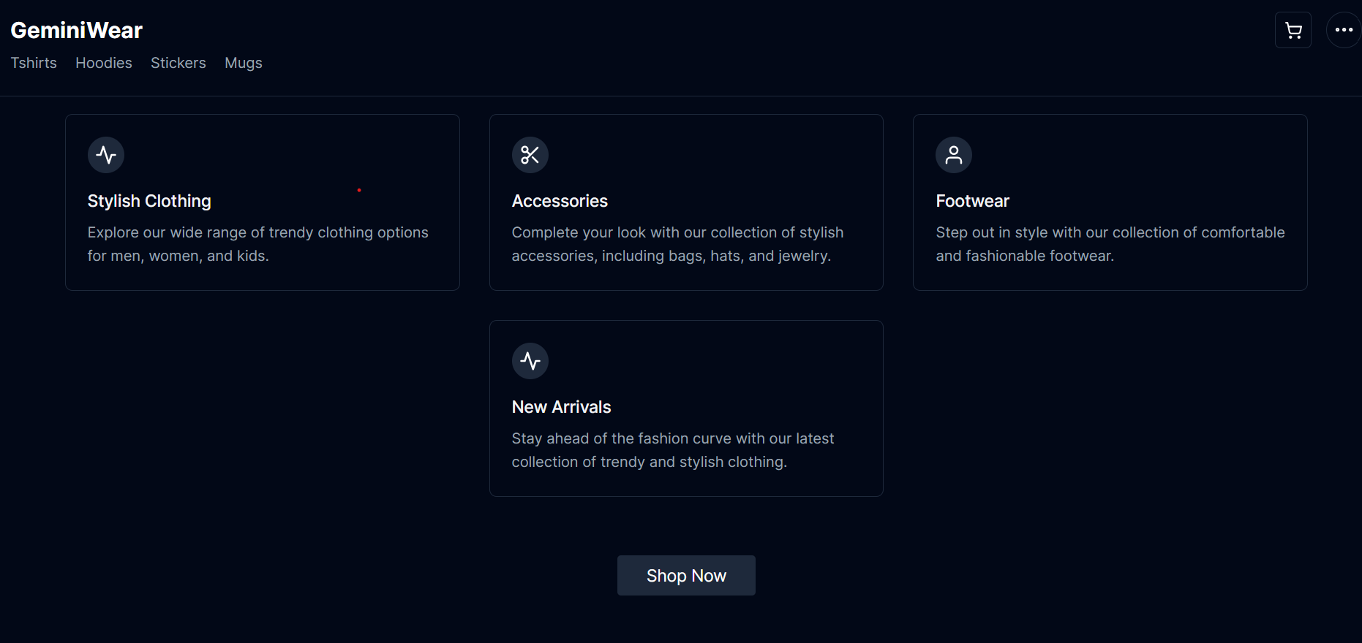

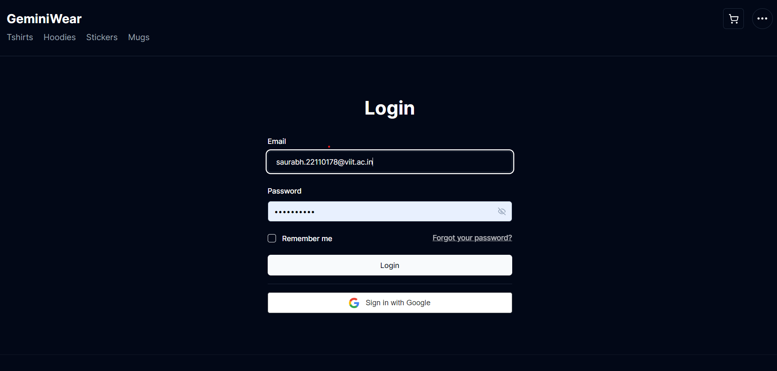

**6. Conclusions**

**6.1 Conclusion -**

In conclusion, the development and implementation of the e-commerce website for the clothing center have yielded significant benefits and outcomes. The project has successfully addressed the initial objectives of establishing an effective online presence, improving customer engagement, and enhancing operational efficiency. Key conclusions drawn from the project include:

* Successful Online Presence: The e-commerce website has provided the clothing center with a robust online platform to showcase its products and services, expanding its reach to a wider audience beyond its physical location.
* Improved Customer Experience: The user-friendly interface, intuitive navigation, and convenient features of the website have contributed to an enhanced shopping experience for customers. By offering personalized recommendations, secure payment processing, and responsive customer support, the website has fostered greater satisfaction and loyalty among users.
* Operational Efficiency: The implementation of automated inventory management, order processing, and fulfillment workflows has streamlined operations for the clothing center. By optimizing stock levels, preventing stockouts, and improving order accuracy, the website has enhanced operational efficiency and reduced costs.
* Financial Impact: The e-commerce website has likely led to increased sales revenue for the clothing center, tapping into new markets and driving online transactions. Cost savings achieved through reduced overhead costs and improved inventory management have further contributed to improved profitability.

Overall, the successful development and deployment of the e-commerce website mark a significant milestone for the clothing center, positioning it for continued growth and success in the digital marketplace.

**6.2 Future Work**

While the e-commerce website has achieved considerable success, there are opportunities for further enhancement and expansion. Future work may include:

* Continuous Optimization: Regular monitoring and optimization of the website's performance, user experience, and conversion rates to adapt to evolving customer needs and market trends.
* Advanced Personalization: Implementing advanced personalization techniques, such as machine learning algorithms, to provide even more accurate product recommendations and tailored shopping experiences for users.
* Internationalization: Expanding the website's reach to international markets by offering multilingual support, localized content, and currency conversion capabilities to cater to diverse customer demographics.

**6.3 Applications**

The e-commerce website developed for the clothing center has broader applications beyond the apparel industry. Similar platforms can be adapted and applied to various sectors including:

* Retail: Other retail sectors such as electronics, home goods, beauty, and lifestyle products can benefit from the implementation of e-commerce websites to expand their online presence and reach a wider customer base.
* Services: Service-based businesses such as travel agencies, restaurants, and fitness centers can leverage e-commerce platforms to offer online bookings, reservations, and appointment scheduling for enhanced customer convenience.
* B2B Commerce: Business-to-business (B2B) companies can utilize e-commerce solutions for streamlining procurement processes, managing supplier relationships, and facilitating online transactions between businesses.
* Marketplaces: Online marketplaces can bring together multiple sellers and buyers onto a single platform, offering a wide range of products and services from various vendors to consumers, creating a dynamic and competitive marketplace ecosystem.

In summary, the applications of e-commerce websites are diverse and versatile, offering opportunities for businesses across industries to innovate, grow, and thrive in the digital age.

## 